Name : Abhishek Anil Patil
Roll No. : 08
PRN No. : 12414243
Assignment: 1

The Problem-Solving Life Cycle and Its Applications
1. The Problem-Solving Life Cycle
The problem-solving life cycle is a systematic approach to finding solutions to problems. It generally involves the following steps:
- Define the Problem: Clearly identify the problem, its constraints, and the desired outcome.
- Understand the Problem: Gather more information, analyze the problem from different angles, and identify key factors.
- Generate Possible Solutions: Brainstorm various potential solutions without immediately judging their feasibility.
- Evaluate the Solutions: Analyze each potential solution based on feasibility, effectiveness, resources required, and potential risks.
- Select the Best Solution: Choose the solution that best meets the criteria and constraints identified in the previous steps.
- Implement the Solution: Put the chosen solution into action.
- Review and Evaluate: Assess the effectiveness of the implemented solution and make adjustments if necessary.
2. Application to Problem 1: The River Crossing Puzzle
Problem Statement:
There is a goat, a tiger, a man, and a bundle of grass on one side of a river. There is a boat that can only carry two at a time and can only be rowed manually by the man. How can they cross the river?
Applying the Problem-Solving Life Cycle:
- Define the Problem:
  - Goal: To get the goat, tiger, man, and grass safely to the other side of the river.
  - Constraints:
    - The boat can carry a maximum of two at a time.
    - The man must row the boat.
    - The goat and tiger cannot be left alone together.
    - The goat and grass cannot be left alone together.
- Understand the Problem:
  - We need to find a sequence of boat trips that moves everyone and everything across the river without violating the constraints.
  - The man is the only one who can operate the boat.
  - We must consider the state of both sides of the river after each trip.
- Generate Possible Solutions:
  - This problem requires considering different combinations of who or what the man takes on each trip.
- Evaluate the Solutions:
  - We must check if each potential trip adheres to the constraints.
- Select the Best Solution:
  - The following sequence of moves solves the problem:
Algorithm:
- The man takes the goat across the river.
- The man returns alone.
- The man takes the tiger across the river.
- The man brings the goat back to the original side.
- The man takes the grass across the river.
- The man returns alone.
- The man takes the goat across the river.
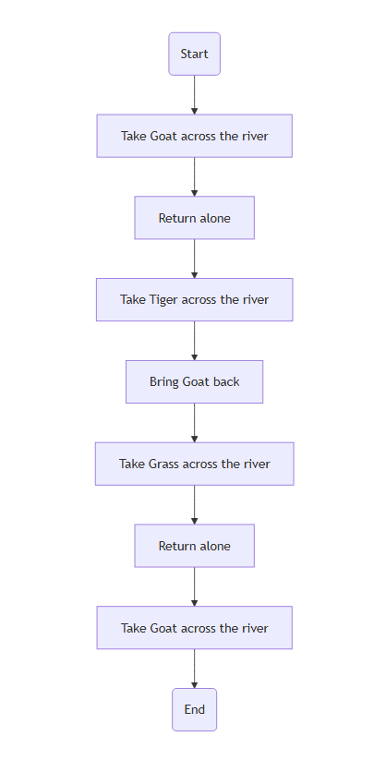
Flowchart:

- Implement the Solution:
  - The algorithm provides the steps for implementation.
- Review and Evaluate:
  - The algorithm ensures that all constraints are met, and everyone and everything is safely transported across the river.
3. Application to Problem 2: The Temple Flowers
Problem Statement:
There are four temples, one plant of flowers, and a pond. A boy goes there, and before entering the first temple, he plucks a flower and takes a bath in the pond before entering every temple. The specialty of the pond is that if a person is carrying flowers with him and takes a dip, the number of flowers doubles. He takes a dip and offers some flowers in the first temple, then again takes a dip and offers flowers in the second temple, and again the same in the third temple. The boy offers an equal number of flowers in all three temples and goes back with empty hands after offering flowers in the third temple. How many flowers could he have offered in each temple?
Applying the Problem-Solving Life Cycle:
- Define the Problem:
  - Goal: Determine the number of flowers the boy offered at each of the three temples.
  - Constraints:
    - The boy starts with one flower.
    - The number of flowers doubles after each dip in the pond.
    - The boy offers an equal number of flowers at each temple.
    - The boy ends with zero flowers after offering flowers at the third temple.
- Understand the Problem:
  - This is a reverse calculation problem. We know the final state (0 flowers) and need to work backward.
  - The number of flowers changes predictably: doubles after a dip and decreases by a fixed amount after offering.
- Generate Possible Solutions:
  - We can use algebra or work backward, assuming a number of flowers offered at each temple.
- Evaluate the Solutions:
  - Let 'x' be the number of flowers offered at each temple. Working backwards:
    - After the 3rd offering: 0 flowers. Before offering: x flowers.
    - Before the 3rd dip: x/2 flowers.
    - After the 2nd offering: x/2 flowers. Before offering: x/2 + x = 3x/2
    - Before the 2nd dip: 3x/4
    - After the 1st offering: 3x/4. Before offering 3x/4 + x = 7x/4
    - Before the 1st dip: 7x/8
    - Initially: 7x/8 = 1
Solving for x, we get x = 8/7.
- Select the Best Solution:
x = 8/7
- Implement the Solution:
  - The boy offered 8/7 flowers at each temple.
- Review and Evaluate:
  - The solution satisfies all the conditions of the problem.

Algorithm:
- Initialize the number of flowers the boy starts with to 1.
- Temple 1:
  - Dip in the pond: Double the number of flowers.
  - Offer 'x' flowers.
- Temple 2:
  - Dip in the pond: Double the number of flowers.
  - Offer 'x' flowers.
- Temple 3:
  - Dip in the pond: Double the number of flowers.
  - Offer 'x' flowers.
- The boy has 0 flowers left.
- Solve the equation derived from the above steps (working backward) to find the value of 'x'. The equation is 8 - 7x = 0, so x = 8/7.

Flowchart:
